# Logging a Maintenance Activity

A logging system for all of the instruments on base was implemented in 2018. The logging scripts and data can be found on the data server. Any activities or disturbances to any of the instruments should be logged using this system.

Data that is entered using the logging script is synced with the instrument PC as well as being fed into the influxDB database. From there the log entries can then be displayed live on the Grafana dashboards and read into the monthly reports automatically.

In case an entry needs to be deleted, a separate script needs to be run. This script will then delete the entry from the data server, instrument PC and the influxDB database. This section provides detailed instructions for logging entries, deleting entries and adding new systems.

## Instructions

To log a new activity, run the script: log.sh and follow the instructions, as demonstrated by the following steps:

1. First, the script will display an enumerated list of all the registered systems. It will then prompt for an instrument number, corresponding to the instrument on which the activity is to be logged. Enter the number and then press the Enter key.

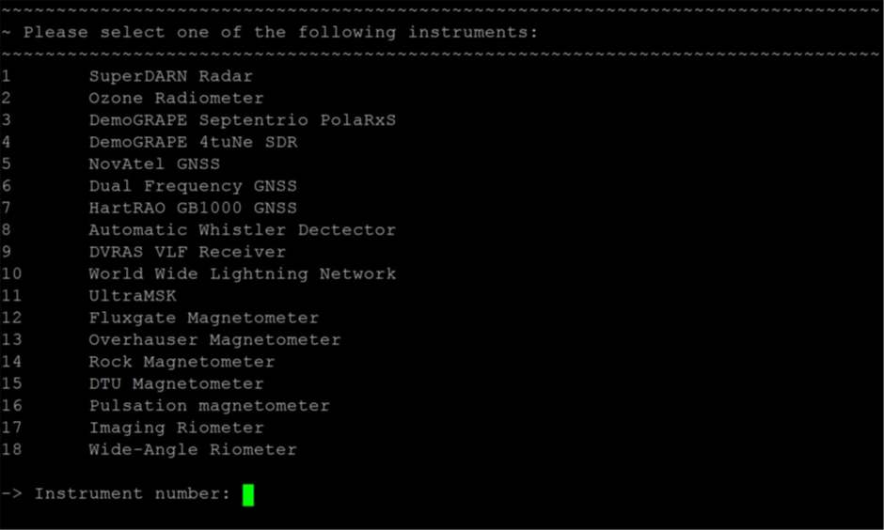

Figure . Logging an activity: Step 1.

1. The next prompt will ask for the name of the person responsible. A default name is displayed, which is read from the universal configuration file. To select the default option provided, simply press the Enter key. If the default name is incorrect, type in the desired name and press Enter.

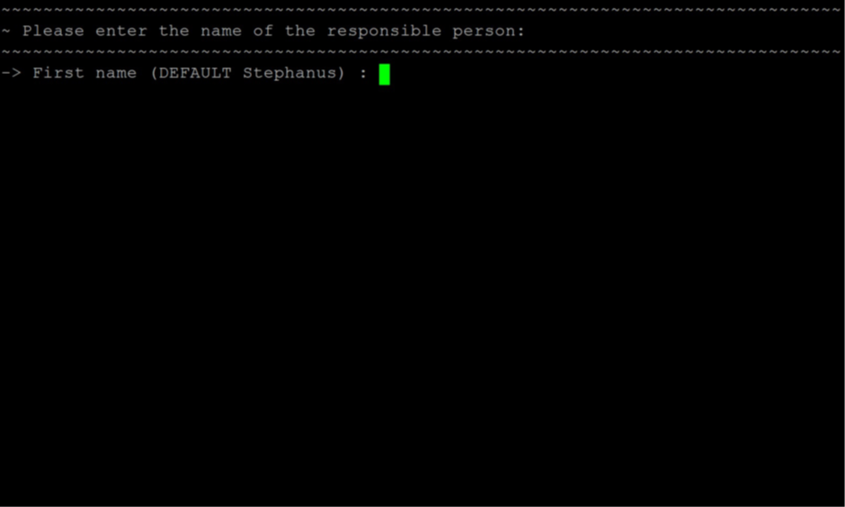

Figure . Logging an activity: Step 2.

1. When asked for the date, once again a default value is displayed. The default date is that of the present day and if the event occurred on a previous day, that date should be entered in the correct format.

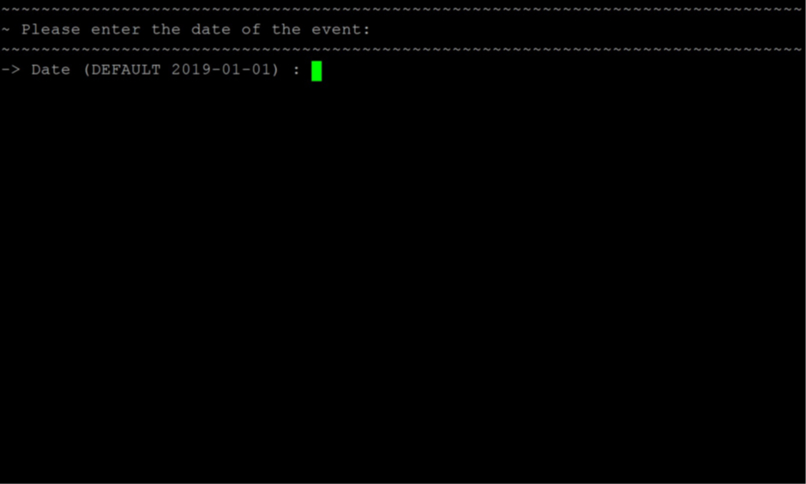

Figure . Logging an activity: Step 3.

1. The time is then prompted, once again with the current time as default. Press Enter or type in the desired time for the event.

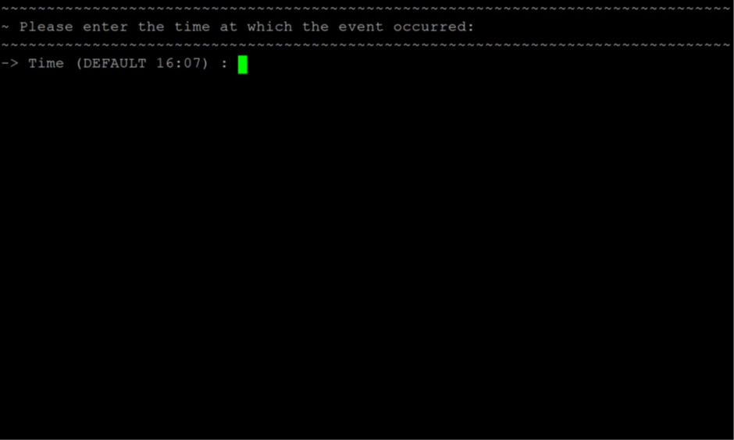

Figure 4. Logging an activity: Step 4.

1. The new status of the system can then be selected from a list of options. These include 0 (the system is off and no data is being logged), 1 (the system is logging data, but interference caused it to be invalid) and 2 (the system is up and logging valid data). Select one of these options and press Enter.

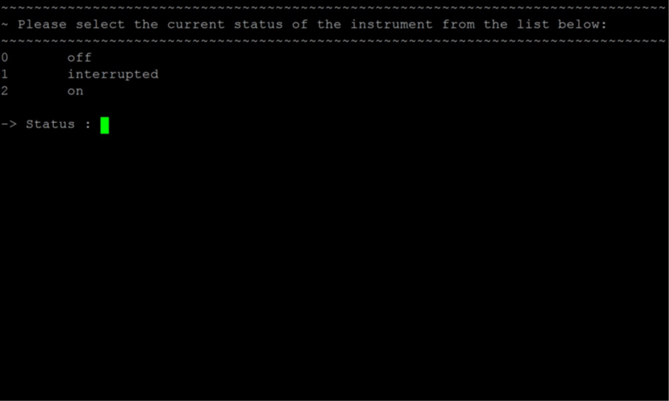

Figure . Logging an activity: Step 5.

1. Finally, the user is asked to elaborate on the reason behind the event. Provide as much information as possible, typing in full sentences. Avoid using special characters as part of this entry. When done, press Enter and wait for the logs to be synchronized and uploaded to the influxDB database.

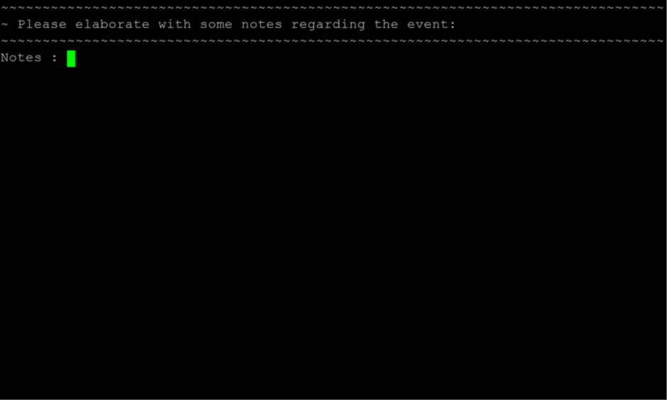

Figure . Logging an activity: Step 6.